SPECIAL REGULATIONS

Rallye Prague Revival 2023

UAMK Club Event

- Programme

Friday 21.04.2023 08,00 – 15,00 Shakedown / not mandatory/, Thursday all day

09,00 – 12,00 Administrative check – Kart Centrum Radotín
GPS 49.9896542N, 14.3747297E

09,00 – 12,30 Scrutineering - at the start area in Kart Centrum
Radotín (EDDA Tent)

12,00 Ceremonial start – Prague City Centre
GPS 50.0893281N, 14.4156172E
12,20 SS 01 Hippodrome, GPS 50.0069369N, 14.3886344E
15,15 Meeting

16,15 Start of 1st Stage, Kart Centrum Radotín

18,45 Finish – Hotel Stará Živohošť
GPS 49.7590744N, 14.4183103E

Saturday 22.04.2023 08,45 Start of 2nd Stage

11,30 Lunch “Špejchar u Vojty” Holašovice
GPS 48.9699058N, 14.2730428E

19,00 Finish – Hotel Stará Živohošť

Sunday 23.04.2023 09,30 Start of 3rd Stage

14,30 Finish - Kart Centrum Radotin, early arrival allowed

18,00 Ceremony- Restaurant Kart Centrum Radotín

ATTENTION! The times may change slightly!

- Organizing committee, officials

Press spokesman Kotek Petr mob. +420 608 960 111
Organizing secretary Švábek Oldřich mob. +420 724 037 619

Officials

Director Patera Eduard
Sport commissioner Malík Jaroslav
Chief scrutineer Fürst Petr

Complaints Švábek Oldřich

SS sections chiefs Ejem Jan
Široký Antonín
Flosman Petr

Contact with crews Holická Bára
Administr. results Malík Jaroslav, Just Ladislav
Press Center UAMK, Promoteam Praha

Track, Itinerary Patera Eduard

- Official notice board

3.1. All decisions, notification and results will be published on official notice board
in the directorate or at daily finish place (e.g. hotel reception).

3.2. Official website - www.edda.cz

- General provisions

  - The event is organized as a club event of UAMK

  - By registering crews undertake to follow the event rules

  - Each crew is responsible for the technical condition of the car and proper insurance!

4.4. All crews undertake to follow the traffic regulations in the exception of the SS.
Participation on the SS is on your own risk without any liability.

4.5. The organizer reserves the right to change the organization of this event due to force
majeure, or to cancel the event for very serious reasons.
4.6. Abbreviations: PP = Penalty points, TC = Time control, SS = Show section,
RC = Radar control, PC = Passing point control, TRC = Traffic rules control,
TP = Scrutineering

- Track

40% 1st and 2nd class roads, 59% 3rd class local roads, 1% bad quality roads and gravel

Itinerary will be provided at the start and service area. It is blank.

5.1. Service zone and parking is at Kart Centrum in Radotín in area and in front of Brudra company. The complex is locked at night and guarded at night. The service and transport vehicles may be parked there. Cars that arrive on their own are parked in the area of the start. It is not allowed to park any vehicles on parking place for guests of Kart Centrum Radotín.
GPS 49.9921581N, 14.3773572E

5.2. Track length 1st Stage 128 km
2nd Stage 394 km
3rd Stage 143 km
Total 665 km

5.3. There are 11 show sections (SS) on the track - these parts are on closed track.
The crews MUST use helmets and the seat belts MUST be fastened! SS start is 5 min. after TC! Finish is of a STOP type!!! You must stop your car between the Stop sign and the traffic cone /10m/. If you don´t stop between the cones you will get 10 PP. If you don´t stop at all you will get 100 PP. Each second time = 1 PP. Knocking down traffic cone = 10 PP each. These sections are optional! If you not participate in this section, you will get the time of the last crew in your class which participated at SS.

SS 01 50% asphalt, 50% interlocking paving with grass
SS 02 100% asfalt, GPS 49.9802583N, 14.4047169E
SS 03,09,10,11 30% asphalt, 70% gravel, GPS 49.6701811N, 14.4300369E
SS 04,06,08 100% asphalt, GPS 49.2744667N, 14.4856553E
SS 05,07 100% asphalt GPS 48.9858336N, 14.4573097E

Each crew must drive in such a way to be able to stop it´s car in the event of a problem on the track!

5.4. PC - Pass control – checked by GPS, missing of PC = 100 PP

5.5. RC - Speed Control – radar control. Traffic rules in CZ: village 50 km/h, road 90 km/h
The speed at radar control section is measured using data from your GPS. The sections length can vary from hundreds to thousands of meters. The measure method is not an average speed on the section because GPS sends your speed to our system every few seconds. If you get the PP for speeding it doesn´t make a sense to correct navigational errors by speeding.

- speeding PP tolerance is of 5 km/h (in urban) or 10 km/h (rural road) over limit
- each km/h above tolerance = 10 PP / e.g. 64 km/h in village = 90 PP
- more than 30 km/h within urban area (village) – Immediate disqualification!!!

5.6. TC - Time control – will be almost always before and after the SS section.
- will be marked A and B e.g. TC 4A, TC 4B
- TC area starts 1m before the yellow TC sign and ends 1m behind the red TC sign. You can enter the TC area at the appropriate minute or one minute before the arrival / departure time.
- Early arrival to TC = 100 PP each minute
- Late arrival to TC = 10 PP for each started minute, max. of 100 PP
- Early/late departure from TC without the Commissioner's stamp = 10 PP for each started minute

Cars with engine less than 1000ccm have following time tolerance:
- cross section less than 25km + 1min
- cross section more than 25km + 2min

ATTENTION!!!
A 10PP for every +/- minute applies even if the time between TC A and TC B is not followed. The correct break time is indicated on the timecard! If you arrive late at TC A, this limit is not to be followed and the crew shall place in their original place according to the start number (or as close as possible to the original place). In such case, the TC Commissioner MUST stamp your ticket on your request! Your break is shortened by the time you arrived late at TC A!
In the next cross section, the commissioner can start a maximum of two cars in the same minute. In such a case, the crew with the lower start number is obliged to return to the original place according to the starting order at the next opportunity.

An example (explanations for circled numbers):
1. Actual departure time from TC 5B
2. Ideal time of arrival in TC 6A
3. The actual arrival time to TC 6A is + 2min, so 20 PP are applied
4. The actual departure time from TC 6B is 21min after the ideal arrival,
therefore it is -2min compared to the actual time of arrival to TC6 A + 21min
5. Stamp confirming departure -2 min from TC 6B, so 0 PP are applied
If the stamp is missing, it counts as a departure 2 minutes early without permission, 20 PP are applied. The stamp must be checked (or asked for) by the crew. The commissioner can´t and shall not count time instead of the crew.

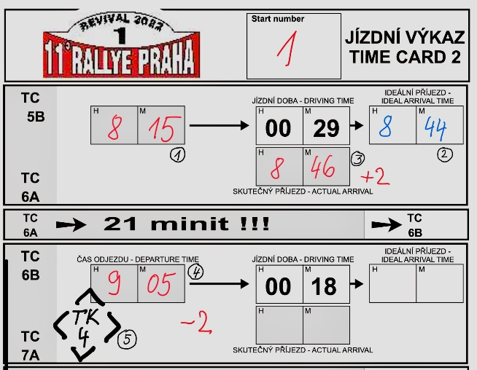

5.7. TRC - Traffic rules control
- for not stopping at the STOP traffic sign = 100 PP
- for passing the traffic light if red light is on = 500 PP

5.8. Mileage and Tripmaster zeroing:
Mileage counting starts at the appropriate TC. If the TC is located e.g at a hotel, it is marked as 0.0 in the roadbook at the first junction. Zeroing: in the case of a roundabout, always at the beginning of the roundabout, in the case of an intersection, at the beginning of the intersection. At the motorway exit at the point where the dashed line changes into a continuous line.

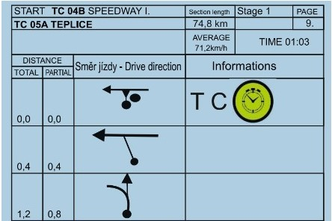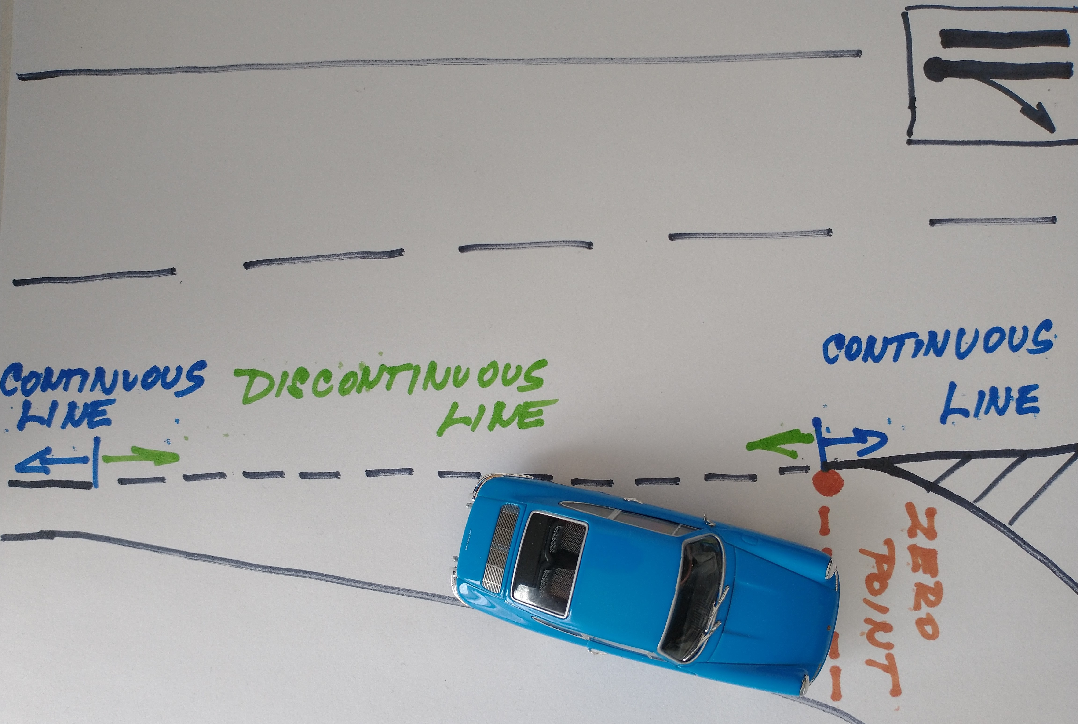
TC position can vary, zeroing on the junction Zeroing on the highway

6. The Cars

6.1. The Event is proposed for historic cars up to 1985. For cars up to January 1990 additional base penalty of 250 PP applies. The relevant year is the year the car was put on sale to customers.

6.2. Classes

1. = A1- 1150ccm 5. = A2- 1150ccm 9. = cars with penalty to 1600ccm
2. = A1- 1600ccm 6. = A2- 1600ccm 10. = cars with penalty over 1600ccm
3. = A1- 2000ccm 7. = A2- 2000ccm
4. = A1+2000ccm 8. = A2+2000ccm

When using newer essential elements in the car, the year is assessed according to this more modern element. E.g. Škoda 1000MB and 1300cc engine with aluminum head = 85PP same as Škoda 130 LR.

6.3. The crew reports the class of their car to the scrutineer at the technical scrutineering (TP). The scrutineer can transfer the car to correct class any time during the event. The technical scrutineering must be completed in the marked classes before the administrative acceptance.

6.4. The allowed adjustment for A1 may be found in section “VŠE O RALLYE” at the www.edda.cz/mscrdovrchu/

6.5. Each car gets penalty points corresponding to its model production year.
For example:
Lada VFTS – production 1984 = 84 PP
Ford Sierra Cosworth – production 1986 = 86 PP + 250 PP
VW Golf GTI I. – production 1976 = 76 PP

7. Applications

Registration by email to x.racing@seznam.cz.

8. Start fee

Start fee is 4 900 CZK / 200 EURO

9. Liability and insurance

All crews start on their own responsibility and risk. The organizer disclaims all responsibility towards competitors, riders, support staff and third parties. ATTENTION: there is no compulsory liability on the SS sections and the driver is responsible for all damages caused by him, which he will immediately cover at his own expense! Each competitor and driver are fully responsible for the validity of their insurance.

10. Administrative scrutineering

Administrative scrutineering will be held according to the schedule in the tent in Kart Centrum. A refundable deposit of 100 euro / 1000 CZK for GPS units will be collected.

11. Technical scrutineering (TP)

TP must be completed before administrative check, at the place of event start. The technical scrutineering is mandatory only for cars of class 1-4!

12. Complaints

Complaints must be made by the time specified/marked on the results board. During the competition then no later than the next day BEFORE the start to the next stage in the office of the race directorate. The complaint will be assessed by designated official.

Complaints during the event (when on road) must be written down on the back side of the timecard with a description: what is claimed, why it is claimed, the TIME of the event must be marked, and/or the starting number of the crew, which can prove the fact of complaint and what happened.

An administrative fee of CZK 100 will be charged for radar/speeding associated complaints. If the complaint is accepted, this fee will be refunded!

13. Results, classification

13.1. The crews will be classified by the sum of PP points in the class; summed up all SS, TC, PC, RC, TRC and additional penalty.

13.2. Results list in classes and overall ranking will be available at the directorate around 50 minutes after the last car arrives at the Finish. The directorate can adjust this time according to current needs.

13.3. The crew who retires on Friday or Saturday can start again next morning. It will get the same time as the last crew in the same class.

13.4. The car can be replaced/changed during the event only with the direct consent of the director, this also applies to the co-driver change! When replacing the car the crew will be reassigned to the appropriate class. In the event of a transfer the correct class is decided by the race directorate.

13.5. Special categories and CUPs (e.g. FOREIGN LEGENDS) will be announced at start.

Jaroslav Malík Eduard Patera
Sport commissioner Event Director

